Contents

Project Overview 1

Architecture Diagram 3

Flow of data 3

Services/ Tools used 4

Storage Access / mounting 4

Folder Structure/notebook organization 6

Data Loading 8

Full Load 8

Incremental Load 8

Scheduling 8

## Project Overview

This is a project for tracking events on a quotation website. In this particular project we are tracking landing, user profile, quotation, events and sales event on a website. At each event we track some information of user for example.

At time of landing we capture information like browername, ostype, ipaddress, device etc.

User’s DOB, EmailAddress, City, State is stored as user profile.

Data of provided quotation like QuotationAmount, Organisation Name, type of package is stored in quotation.

User Action after receiving quotations is tracked under Events & Policy details.

All the data being used in this project is fake and auto generated. In the landing zone/raw we have csv, tsv & json files containing data of each entity.

Data from raw layer is loaded into bronze layer as it is in Delta Tables.

As I have been following the medallion architecture, cleaned data from bronze layer is read, cleaned and loaded to silver layer in Delta tables.

And in the last stage curated, calculated data is loaded to gold layer in form of facts and dimensions.

At every later I have used a structure, watermark to support incremental or bulk load of data. This structure hold the timestamp of last run of data populate.

## Architecture Diagram

raw is the landing zone, I have data in csv, tsv & json format in this layer.

Bronze is the raw layer, data from raw/landing zone is copied to bronze layer as is without any modification.

Silver layer hold cleansed data with additional entities and details like ingestion date, understandable column names etc.

Gold layer is the datawarehouse layer where data is stored in facts and dimensions.

## Flow of data

## Services/ Tools used

Azure Data Bricks 🡪 Cleaning & loading data

Azure Data Lake 🡪 Data Storage

Azure Key Vault 🡪 Secured storage for access token

Azure Active Directory 🡪 User Authentication

Azure Data Factory 🡪 Scheduling and Execution

Azure Delta Tables 🡪 Silver & Gold layer storage format

Spark SQL 🡪 Data querying and cleaning

## Storage Access / mounting

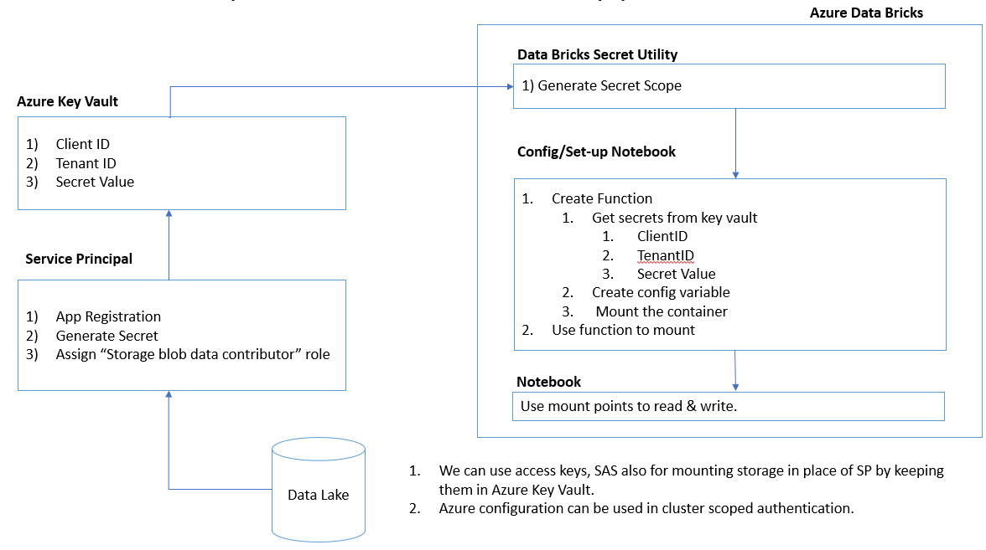

For authenticating to Data Lake, I have used session scoped credentials using Service Principal. Client Id and secret value of Data lake is stored in Azure key vault which is read by Databricks Secret Utility. For mounting data storage I have created a notebook and mounted required containers.

here in above example

1. Reading client_id, tenant_id and client_secret from databricks secret utility which is further reading data from Azure Key Vault.
2. Created a function “mount_adls” which is used to mount the data lake containers.
3. Once container “dev” is mounted, the mounted container can be directly used in any notebook instead of using configuration again and again.

## Folder Structure/notebook organization

At the top level I have “notebooks” folder which has 2 main folders.

1. Common : Contain common code for mounting storage location.



1. WebTrackingDW
   1. Executor
   2. Load
   3. Set up

In set-up folder I have created notebooks for common configuration like creating variables to read storage layer, defining database schema for bronze, silver and gold.

In load folder there are notebooks to cleanse and move data from one layer to another.

Finally executor folder holds notebooks to call, data loading notebooks in order for Full Load or Incremental load.

## Data Loading

### Full Load

1. Create notebooks _setfullload from load folder to truncate all the tables and reset watermarkvalue.
2. Call notebooks to load data from scratch using dbutils.notebook.run.

### Incremental Load

1. Call notebooks to load data, the notebooks will read last populated timestamp from watermark table and process only incremental data.

## Scheduling

Here I have used Azure Data Factory “data bricks” task to schedule the entire process.

